Use-Case Realization Report
AddUser

Issue <1.0>
Revision History
Date | Issue | Description | Author
<02/08/09> | <1.0> | <Add User> | <Karen Gao>

Table of Contents
1. Brief Description 4
2. Flow of Events 4
2.1 Standard Flow 4
2.2 Exceptions 4
3. Interaction Diagrams 5
3.1 Collaboration Diagram for AddUser 5
4. Participating Objects 5
5. Class Diagrams 6
5.1 Class Diagram for AddUser 6
6. Derived Requirements 6

Use-Case Realization Report
AddUser

Brief Description
The addition of a new User shall be executed once the duplication check for the existing User list was performed.

Flow of Events

Standard Flow
This use case covers the events of adding User, which is part of the User Maintenance package. The standard flow of events is described as below:
- The User Administrator shall press the button to send out a command of “AddButtonClicked” on the interface of MaintainUserPage.
- Once MaintainUserController received this request, the operation getUserList will get the User list from object of User.
- The MaintainuserController shall perform the check for duplication of record, if not duplication of record is found, it will proceed to the operation getRole from Role object.
- The operation assignRole will assign role to the User object according to the desired.
- Then the updateUserList of the MaintainUserController will update the new list of User object
- Once it’s done, the successful updating userList will show to the MaintainUserPage.

Exceptions

- If there’s duplication found in User Admin records, a warning message will be show to the MaintainUserPage through the operation showUserDuplicatedMsg.

Interaction Diagrams

Collaboration Diagram for AddUser
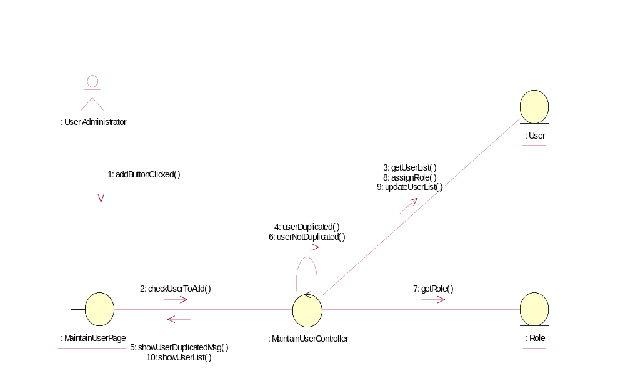

Participating Objects
: MaintainUserController
This controller is to add, delete and update User

: MaintainUserPage
This is a page for adding, deleting, updating and displaying the User

: Role
This Entity is Role object

: User
This Entity is User object

: User Administrator
This Actor is User Administrator object

Class Diagrams

Class Diagram for AddUser
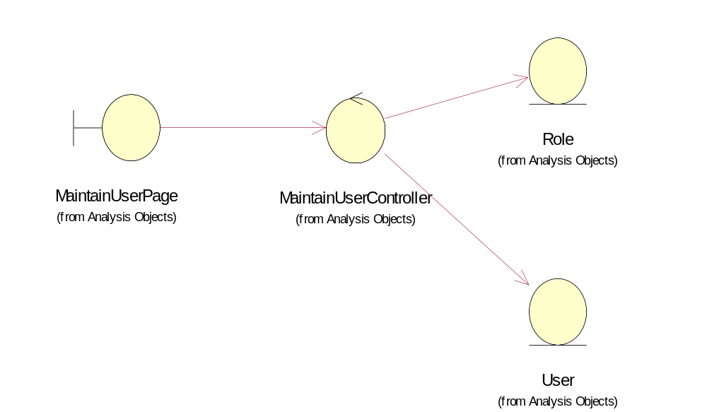

Derived Requirements
User Administrator and Portal Administrator have rights to access this page

